# User’s Manual in English Version

Yuxuan Bai(yuxuan_bai@shu.edu.cn); Qiu-An Huang(hqahqahqa@163.com)

Institute for Sustainable Energy/College of Sciences, Shanghai University, Shanghai 200444, China

## Outline

This document describes the features and the use of the DEIS-Toolbox@LIB, which can be used to calculate galvanostatic charge-discharge (GCD) module, static electrochemical impedance spectroscopy (SEIS) module and dynamic electrochemical impedance spectroscopy (DEIS) module based on the unified framework for Li-ion batteries (LIBs). Numerical details of DEIS-Toolbox@LIB are available in Reference [1]. In the future, both the side reaction itself and the thermal-mechanical effect will be added into the unified framework.

## 1 What is DEIS-Toolbox@LIB？

### 1.1 What can DEIS-Toolbox@LIB do?

Time domain Model Doyle-Fuller-Newman (DFN) for LIBs is based on the concentrated solution theory, porous electrode theory, and Butler−Volmer kinetics [2–4]. Meyers et al. [5–6] introduces a frequency domain Model DFN for LIBs by introducing a description of an electrical double layer at the solid-electrolyte interface.

Frequency domain Model DFN for porous electrodes can be classified into two cases [7]: (i) complete impedance model; and (ii) simplified impedance model. When ignoring Li+ concentration gradient in the pore electrolyte of the full cell, Model DFN can be degenerated into Model B. When ignoring Li concentration gradient in the active particle of negative and positive electrodes, Model B can be degenerated into Model E [7].

**Table 1**. DEIS-Toolbox@LIB based on the time-frequency domain Model DFN.

|  |  |
| --- | --- |
| **Calculating items** | **Description** |
| *c*s(*x*,*r*,*t*), *c*e(*x*,*t*), *φ*s(*x*,*t*), *φ*e(*x*,*t*), *j*(*x*,*t*) | Internal state variables in the time domain Model DFN. |
| *v*1(*t*), *v*2(*t*), *v*3(*t*), *v*4(*t*) | The terminal voltages of the battery components. |
| ${\dot{C}}_{s}\left(x,r,s\right)$, ${\dot{C}}_{e}\left(x,s\right)$, ${\dot{Φ}}_{s}\left(x,s\right)$, ${\dot{Φ}}_{e}\left(x,s\right)$ $\dot{J}\left(x,s\right)$ | Internal state variables in the frequency domain Model DFN. |
| *z*d(*s*), *z*F(*s*), *z*R(*s*), *z*int(*s*) | The static/dynamic solid diffusion, Faradic, Randle, and whole particle impedance on the particle scale. |
| *Z*1(*s*), *Z*2(*s*), *Z*3(*s*), *Z*4(*s*) | The SEIS/DEIS of the battery components in the frequency domain Model DFN. |
| *Z*Ds(*s*), *Z*De(*s*) | The static/dynamic solid diffusion and electrolyte diffusion impedance. |

The main feature of DEIS-Toolbox@LIB is an accurate and computationally efficient simulation of the time-frequency domain Model DFN [2–7] based on the numerical implementation and results presented in Reference [1]. These results have been summarized in Table 1.

### 1.2 How many sub-functions in DEIS-Toolbox@LIB？

In detail, DEIS-Toolbox@LIB mainly consists of 18 sub-functions, i.e., compute_soc.m, computer_cap.m, DFN_time.m, dispstat.m, fcn_Acs_j.m, fcn_Aw.m, fcn_F.m, fcn_J.m, fcn_system_matrices.m, fcn_system_matrices_change.m, fcn_system_vectors.m, parameters_init.m, qinterp1.m, variable_init.m, variables_full_time.m, DFN_frequency.m, frequency_input.m, and variables_full_frequency.m.

#### (1) compute_soc.m

This function computes the state of charge (soc) of the full cell based on the solid phase concentration of the negative electrode.

Inputs:

- p is a MATLAB struct containing the initial parameters.

- cs is solid electrolyte, [mol/m^3].

Outputs:

- soc is the state of charge (soc) of the full cell, [-].

#### (2) computer_cap.m

This function computes the ampere-hour total capacity of the cell and the 1C charge/discharge current density.

Inputs:

- p is a MATLAB struct containing the initial parameters.

- mode is the selection switch for charging or discharging mode.

Outputs:

- NP is a MATLAB struct containing the output variables, such as the 1C charge/discharge current density.

#### (3) DFN_time.m

This function simulates the time domain charge/discharge curve of the DFN model.

Inputs:

- p is a MATLAB struct containing the initial parameters.

- soc_init is the initial state of charge (soc) of the full cell, [-].

- Crate is the charge/discharge rate, [-].

- mode is the selection switch for charging or discharging mode.

Outputs:

- volt is a MATLAB struct containing the output variables, such as the output voltage.

- vari is a MATLAB struct containing the internal variables, such as the concentrations and the potentials.

#### (4) dispstat.m

This function prints a message to the Command Window.

#### (5) fcn_Acs_j.m

This function computes the matrix A_cs at the position x_j in the electrode.

Inputs:

- nr is the number of grid points along the radial coordinate, [-].

Outputs:

- Acs_j is the matrix A_cs at the position x_j for c_s.

#### (6) fcn_Aw.m

This function computes the matrix A_w in the full cell or battery components.

Inputs:

- alpha1 is α_I, refers to D_e,eff, κ_eff, κ_D,eff or σ_eff.

- alpha0 is α_O×δ_x, see to Equation (28-1).

- dx is interval size along the x-dimension.

Outputs:

- Aw is the matrix A_w for c_e, φ_s and φ_e.

#### (7) fcn_F.m

This function computes F_x.

Inputs:

- p is a MATLAB struct containing the initial parameters and their corresponding vector form.

- m is a MATLAB struct containing the system matrix, such as the discretization matrix of the governing equations.

- x is the dependent variable being solved for.

- cs_prevt is solid electrolyte of the previous moment, [mol/m^3].

- ce_prevt is electrolyte electrolyte of the previous moment, [mol/m^3].

- phis_prevt is solid potential of the previous moment, [V].

- phie_prevt is electrolyte potential of the previous moment, [V].

- phisf_prevt is potential in the film close to the solid phase of the previous moment, [V].

- i_app is the applied (dis) charge current density, [A/m^2].

Outputs:

- F_x is function matrix.

- cs is solid electrolyte, [mol/m^3].

- ce is electrolyte electrolyte, [mol/m^3].

- phis is solid potential, [V].

- phie is electrolyte potential, [V].

- j is pore wall flux, [mol/m^2/s].

- phisf is potential in the film close to the solid phase, [V].

- jF is molar flux of Li-ions de-intercalating out of the solid phase, [mol/m^2/s].

- eta is overpotential, η, [V].

- Uocp is open-circuit potential, [V].

- m is a MATLAB struct containing the system matrix, such as the discretization matrix of the governing equations.

#### (8) fcn_J.m

This function computes the Jacobian matrix J_x of F_x.

Inputs:

- p is a MATLAB struct containing the initial parameters and their corresponding vector form.

- m is a MATLAB struct containing the system matrix, such as the discretization matrix of the governing equations.

- cs is solid electrolyte, [mol/m^3].

- ce is electrolyte electrolyte, [mol/m^3].

- jF is molar flux of Li-ions de-intercalating out of the solid phase, [mol/m^2/s].

- eta is overpotential, η, [V].

Outputs:

- J_x is Jacobian matrix of F_x.

#### (9) fcn_system_matrices.m

This function defines the system matrices that do not change in the inner loop, which involves the 10 coefficient matrices in Equations (36-1)-(36-4) and (39-1)-(39-4).

Inputs:

- p is a MATLAB struct containing the initial parameters and their corresponding vector form.

Outputs:

- m is a MATLAB struct containing the system matrix, such as the discretization matrix of the governing equations.

#### (10) fcn_system_matrices_change.m

This function defines the system matrices that do change in the inner loop.

Inputs:

- p is a MATLAB struct containing the initial parameters and their corresponding vector form.

- m is a MATLAB struct containing the system matrix, such as the discretization matrix of the governing equations.

- ce is electrolyte electrolyte, [mol/m^3].

- T is ambient temperature, [K].

- phis_prevt is solid potential of the previous moment, [V].

- phie_prevt is electrolyte potential of the previous moment, [V].

- phisf_prevt is potential in the film close to the solid phase of the previous moment, [V].

Outputs:

- m is a MATLAB struct containing the system matrix, such as the discretization matrix of the governing equations.

#### (11) fcn_system_vectors.m

This function converts the specified parameters into vectors.

Inputs:

- p is a MATLAB struct containing the initial parameters.

Outputs:

- p is a MATLAB struct containing the initial parameters and their corresponding vector form.

#### (12) parameters_init.m

This function defines the parameters used in the simulation.

Inputs:

- no parameters need to be passed in.

Outputs:

- p is a MATLAB struct containing the initial parameters.

#### (13) qinterp1.m

This function uses linear interpolation method for interpolation.

#### (14) variable_init.m

This function defines the initial values ​​of the internal state variables, ie, c_s, c_e, φ_s, φ_e, and j, when t = 0 and i = 0.

Inputs:

- p is a MATLAB struct containing the initial parameters and their corresponding vector form.

- soc_init is the initial state of charge (soc) of the full cell, [-].

Outputs:

- cs is initial solid electrolyte, [mol/m^3].

- ce is initial electrolyte electrolyte, [mol/m^3].

- phis is initial solid potential, [V].

- phie is initial electrolyte potential, [V].

- j is initial pore wall flux, [mol/m^2/s].

#### (15) variables_full_time.m

This function computes the variables on the interface of control volumes by using continuity boundary conditions based on the variables at the center of the corresponding control volume.

Inputs:

- p is a MATLAB struct containing the initial parameters and their corresponding vector form.

- i_app is the applied (dis) charge current density, [A/m^2].

- ce is electrolyte electrolyte, [mol/m^3].

- phie is electrolyte potential, [V].

- phis is solid potential, [V].

- n_t is the number of simulation steps.

Outputs:

- ce_full is electrolyte electrolyte, [mol/m^3].

- phie_full is electrolyte potential, [V].

- phis_full is solid potential, [V].

#### (16) DFN_frequency.m

This function computes the static EIS and dynamic EIS of the DFN-like impedance models based on the input concentration variables.

Inputs:

- f is frequency, Hz.

- p is a MATLAB struct containing the initial parameters and their corresponding vector form.

- m is a MATLAB struct containing the system matrix, such as the discretization matrix of the governing equations.

- cs is solid electrolyte, [mol/m^3].

- ce is electrolyte electrolyte, [mol/m^3].

Outputs:

- vari is a MATLAB struct containing the internal variables, such as the concentrations, the potentials, and charge transfer resistances.

- Z is a MATLAB struct containing the output variables, such as the impedance of different components and diffusion impedance.

#### (17) frequency_input.m

This function selects the corresponding concentration and calculates the EIS based on charge and discharge rate.

Inputs:

- f is frequency, Hz.

- p is a MATLAB struct containing the initial parameters.

- volt is a MATLAB struct containing the output variables, such as the output voltage.

- vari is a MATLAB struct containing the internal variables, such as the concentrations and the potentials.

- Crates is the charge and discharge rate, dimensionless.

- soc_thr is the soc selected for calculating SEIS/DEIS, dimensionless.

- mode is the selection switch for charging or discharging mode.

Outputs:

- state is a MATLAB struct containing the output variables, such as the output impedance and internal state variables.

#### (18) variables_full_frequency.m

This function computes the variables on the interface of control volumes by using continuity boundary conditions based on the variables at the center of the corresponding control volume.

Inputs:

- p is a MATLAB struct containing the initial parameters and their corresponding vector form.

- ce is electrolyte electrolyte, [mol/m^3].

- out is a MATLAB struct containing the internal variables, such as the concentrations and the potentials.

- Model is the selection switch for the complete DFN (CDFN) model or simplified model.

Outputs:

- out is a MATLAB struct containing the internal variables, such as the concentrations and the potentials.

### 1.3 Prerequisites

This toolbox only requires a working version of Matlab. The toolbox has been tested with Matlab R2020a but should work with any Matlab version.

## 2 How to plot figures with DEIS-Toolbox@LIB？

### 2.1 Figures to be plotted

The core of DEIS-Toolbox@LIB is DFN_time.m and DFN_frequency.m, the core inputs of these sub-functions are the internal parameters of the battery, the SOC of the full cell, the charge/discharge rate and the simulation frequency, and the outputs are shown in Table 1. The function, input, and output of each sub-function are shown in section 1.2.

**Table 2**. The functions of main functions for DEIS-Toolbox@LIB.

|  |  |
| --- | --- |
| **Main function** | **Function** |
| Figure_4to9_11to16 | Script used to obtain time-frequency domain datas to demonstrate non-equilibrium state is shown in Figures 4−9 and 11−16. |
| Figure_10 | Script used to obtain time-frequency domain datas to demonstrate the effects of rate is shown in Figure 10. |
| Figure_17to20 | Script used to obtain time-frequency domain datas to demonstrate the effects of *D*e is shown in Figures 17−20. |
| Figure_21to22 | Script used to obtain datas to demonstrate the sensitivity of the solid/electrolyte diffusion impedance *Z*Ds/*Z*De with respect to the parameter set *X* is shown in Figures 21−22. |

In addition, DEIS-Toolbox@LIB consists of 4 main functions, i.e., Figure_4to9_11to16.m, Figure_10.m, Figure_17to20.m, and Figure_21to22.m. The functions of these main functions have been summarized in Table 2. Click these .m files and run immediately without any other toolbox.

### 2.2 How to initialize parameters before plotting？

In the present work, graphite is chosen as the negative electrode, LiCoO2 as the positive electrode, and the liquid/salt/polymer system consisting of a 10:27:63 v/v mixture of propylene carbonate/ethylene carbonate/dimethyl carbonate as the electrolyte, respectively. All default parameter values required by DEIS-Toolbox@LIB simulation and their physical meanings can be found in parameters_init.m.

### 2.3 Examples

The specific steps for using DEIS-Toolbox@LIB are as follows:

(i) Download the DEIS-Toolbox@LIB.zip file from the Supplementary data in Reference [1] and unzip to disk F (this position can be selected by yourself);

(ii) Install and start Matlab R2020a;

(iii) Enter the command cd('F:\DEIS-Toolbox@LIB') in the Command Window to modify the Current Folder, as shown in Figure 1;

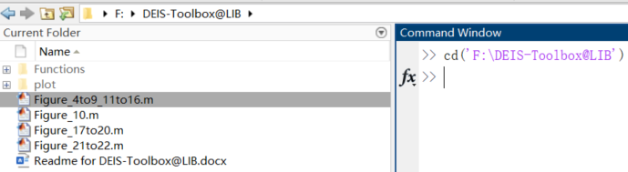

**Figure 1.** Modify the Current Folder of Matlab.

(iv) Open any .m file and click the Run button to execute this file, as shown in Figure 2.

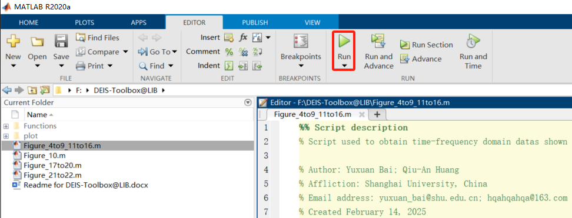

**Figure 2.** Run .m file of Matlab.

Next, specific cases are used to demonstrate the results of the toolbox.

#### (1) Simulation with default parameters

Based on the default parameters, click on the Figure_4to9_11to16.m file, and the user can directly obtain Figures 4−9 and 11−16 in Reference [1]. The location of the .m file is shown in Figures 1–2 and the corresponding simulation results are shown in Figures 3−5.

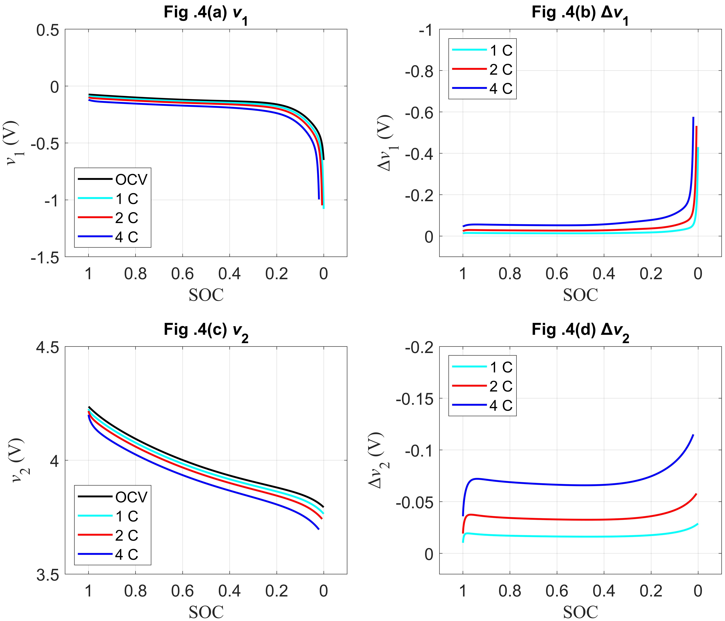

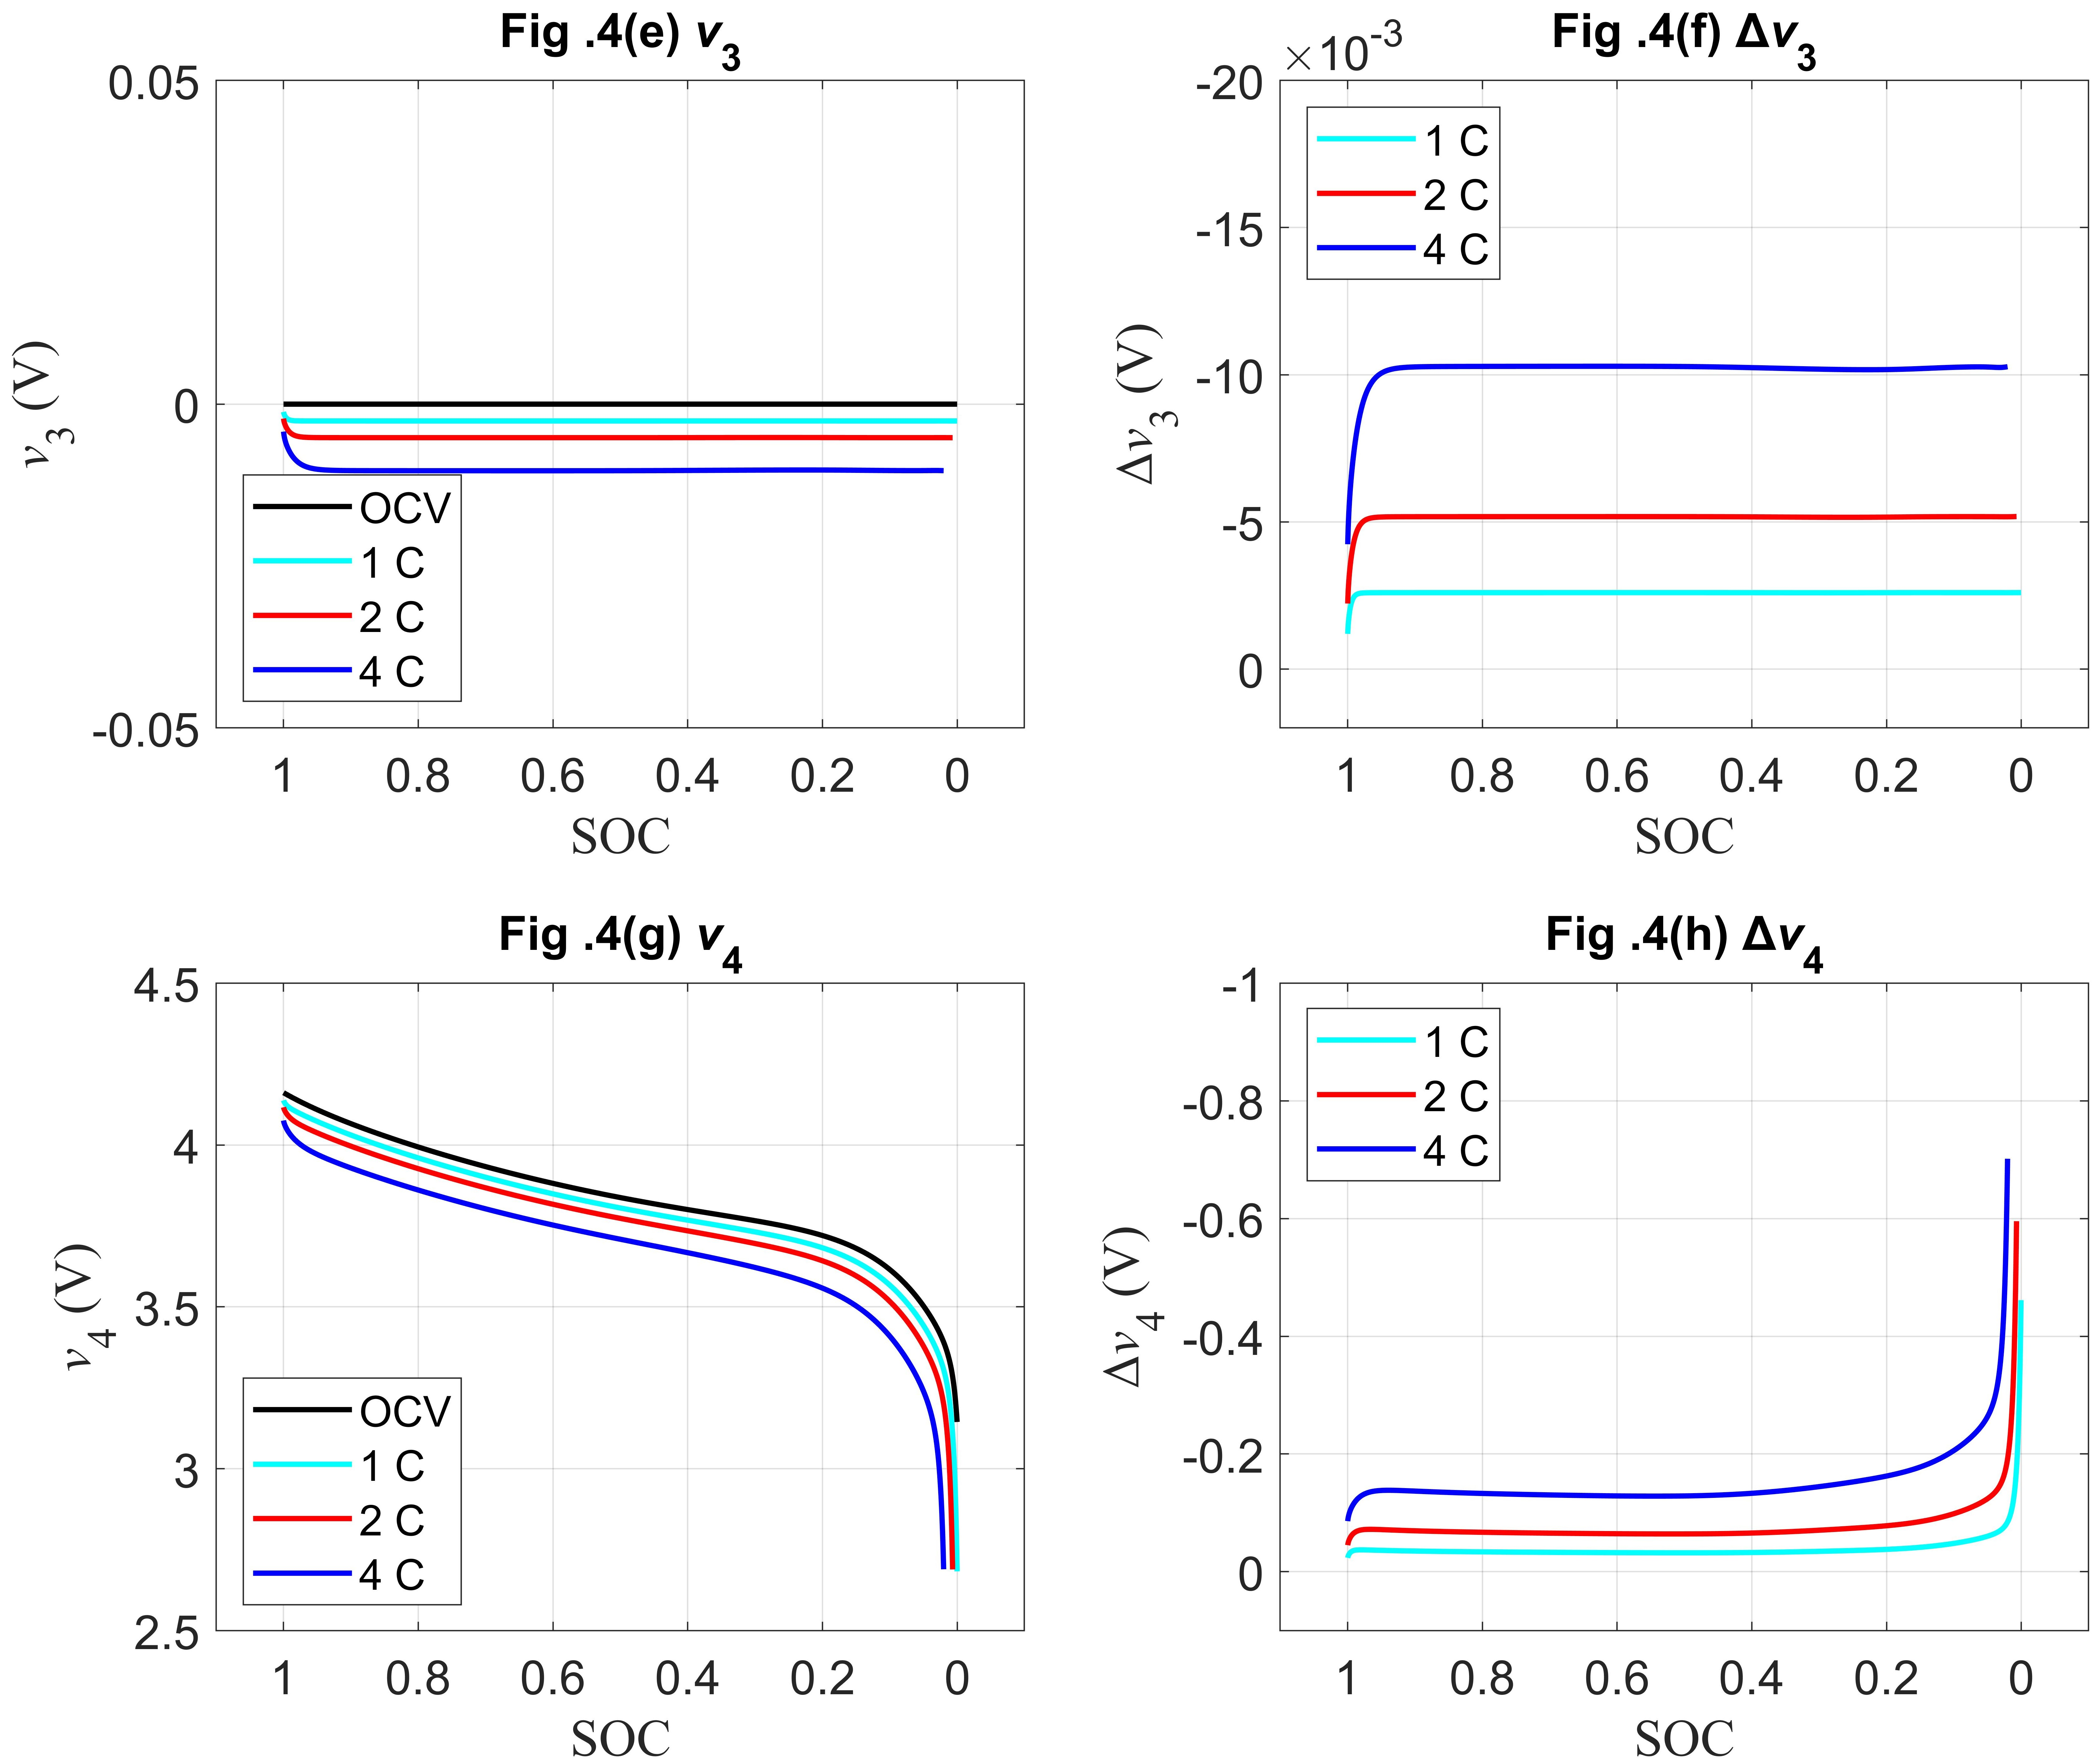

**Figure 3.** The terminal voltages *v*i(*t*) (i = 1,2,3,4) and their absolute deviations Δ*v*i(*t*) compared to their open circuit voltages *U*ocp with respect to SOC at different discharge rates. (a) *v*1(*t*) & (b) Δ*v*1(*t*) for the negative electrode; (c) *v*2(*t*) & (d) Δ*v*2(*t*) for the positive electrode; (e) *v*3(*t*) & (f) Δ*v*3(*t*) for the separator; and (g) *v*4(*t*) & (h) Δ*v*4(*t*) for the full cell.

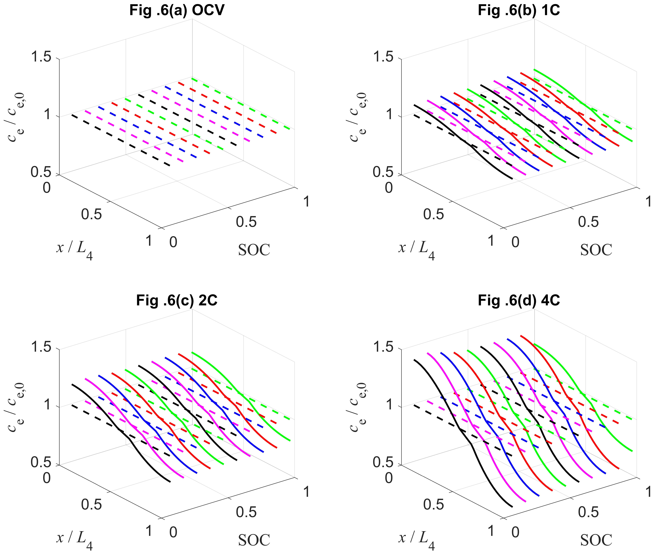

**Figure 4.** The evolution trend of *c*e(*x*,*t*) for the full cell with respect to spatial location *x* and SOC, compared to the OCV situation, at different discharge rates: (a) 0C or under OCV condition; (b) 1C; (c) 2C; (d) 4C.

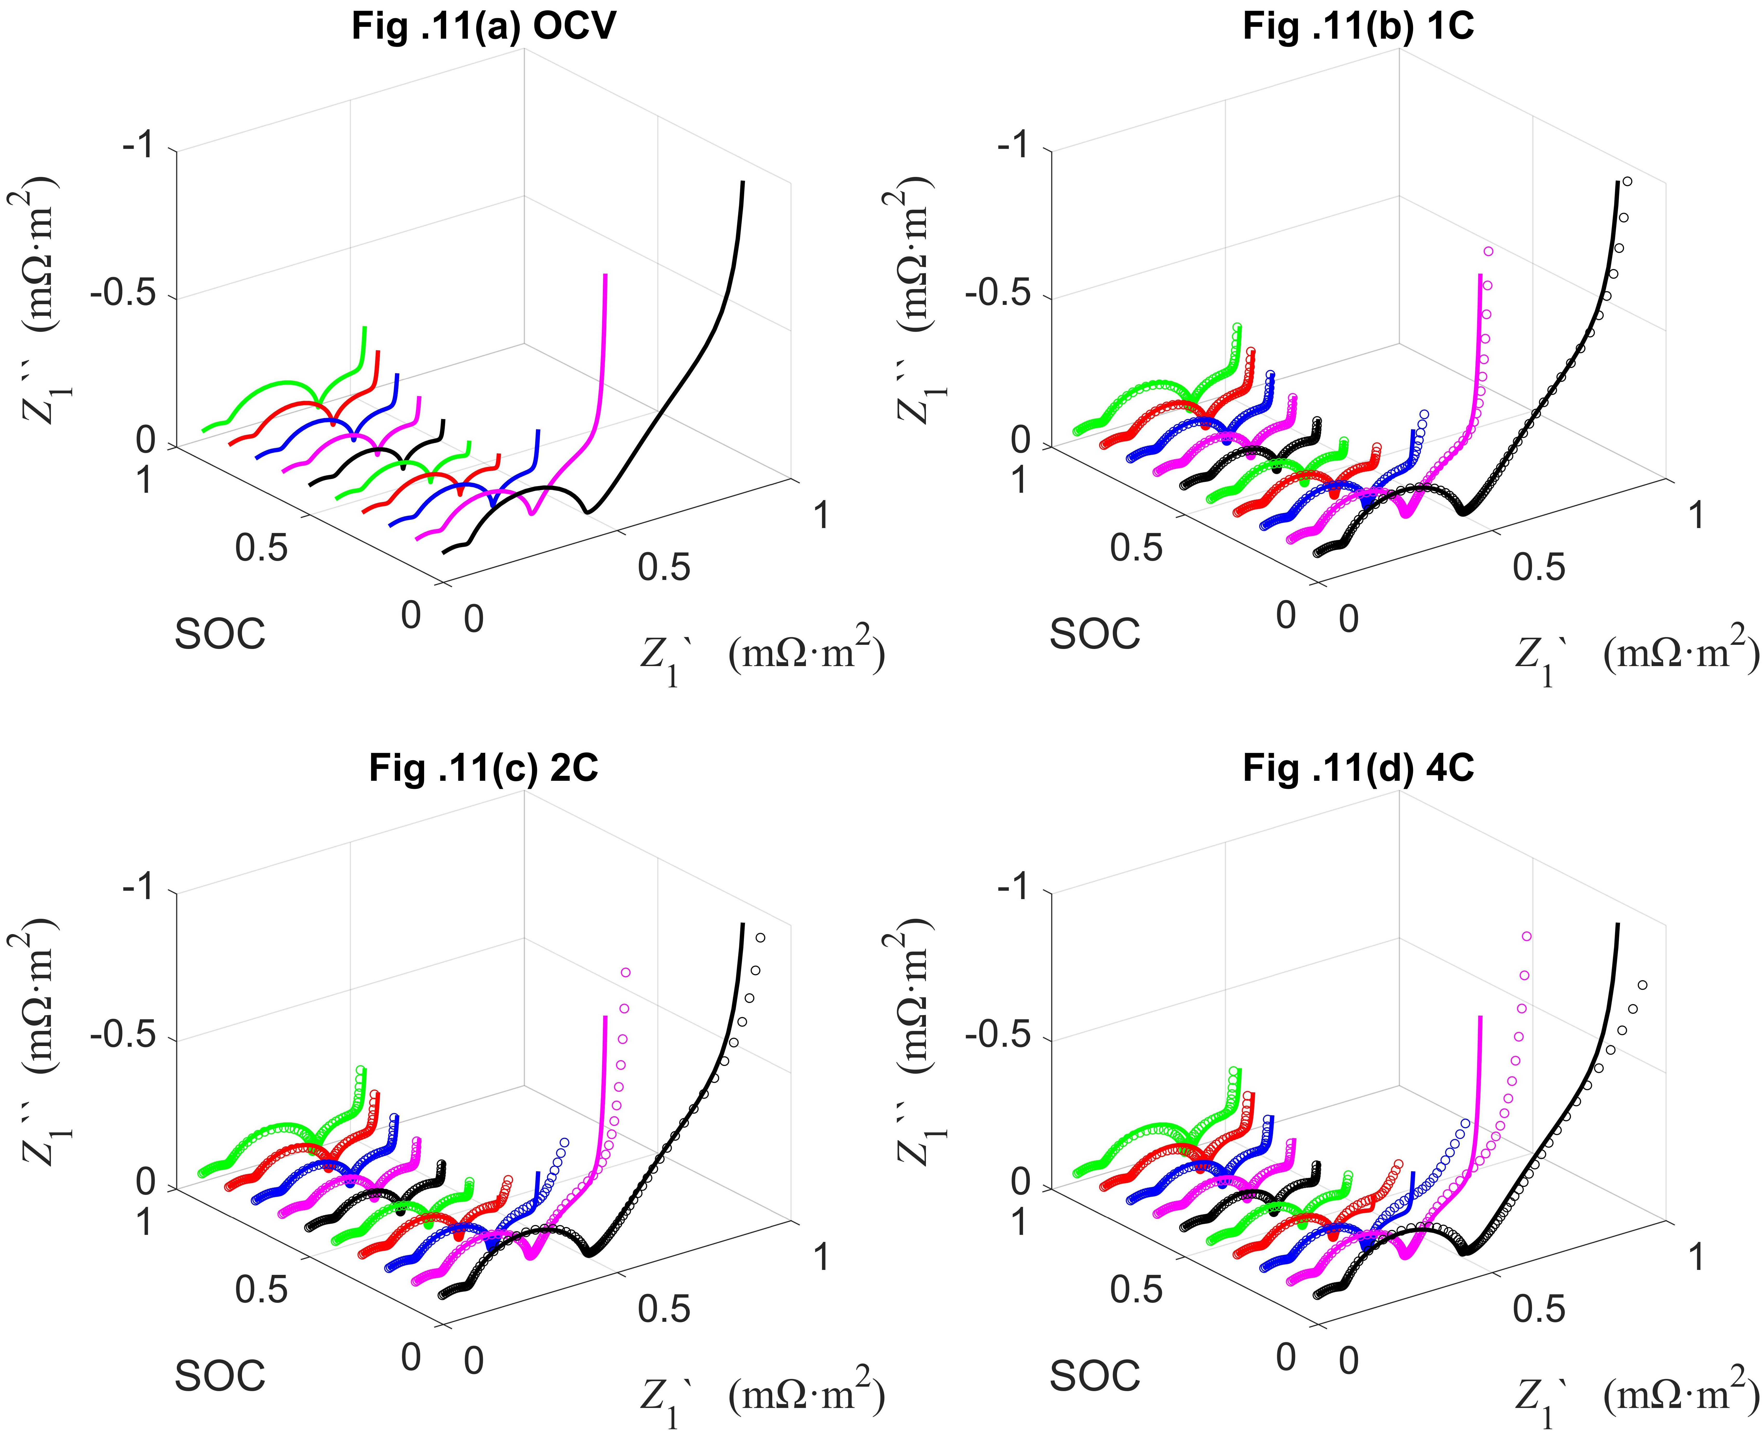

**Figure 5.** The evolution trend of DEIS compared to SEIS for the negative electrode with respect to SOC at different discharge rates: (a) 0C or under OCV condition; (b) 1C; (c) 2C; (d) 4C.

Based on the default parameters, click on the Figure_10.m file, and the user can directly obtain Figure 10 in Reference [1]. The location of the .m file is shown in Figures 1–2 and the corresponding simulation results are shown in Figure 6.

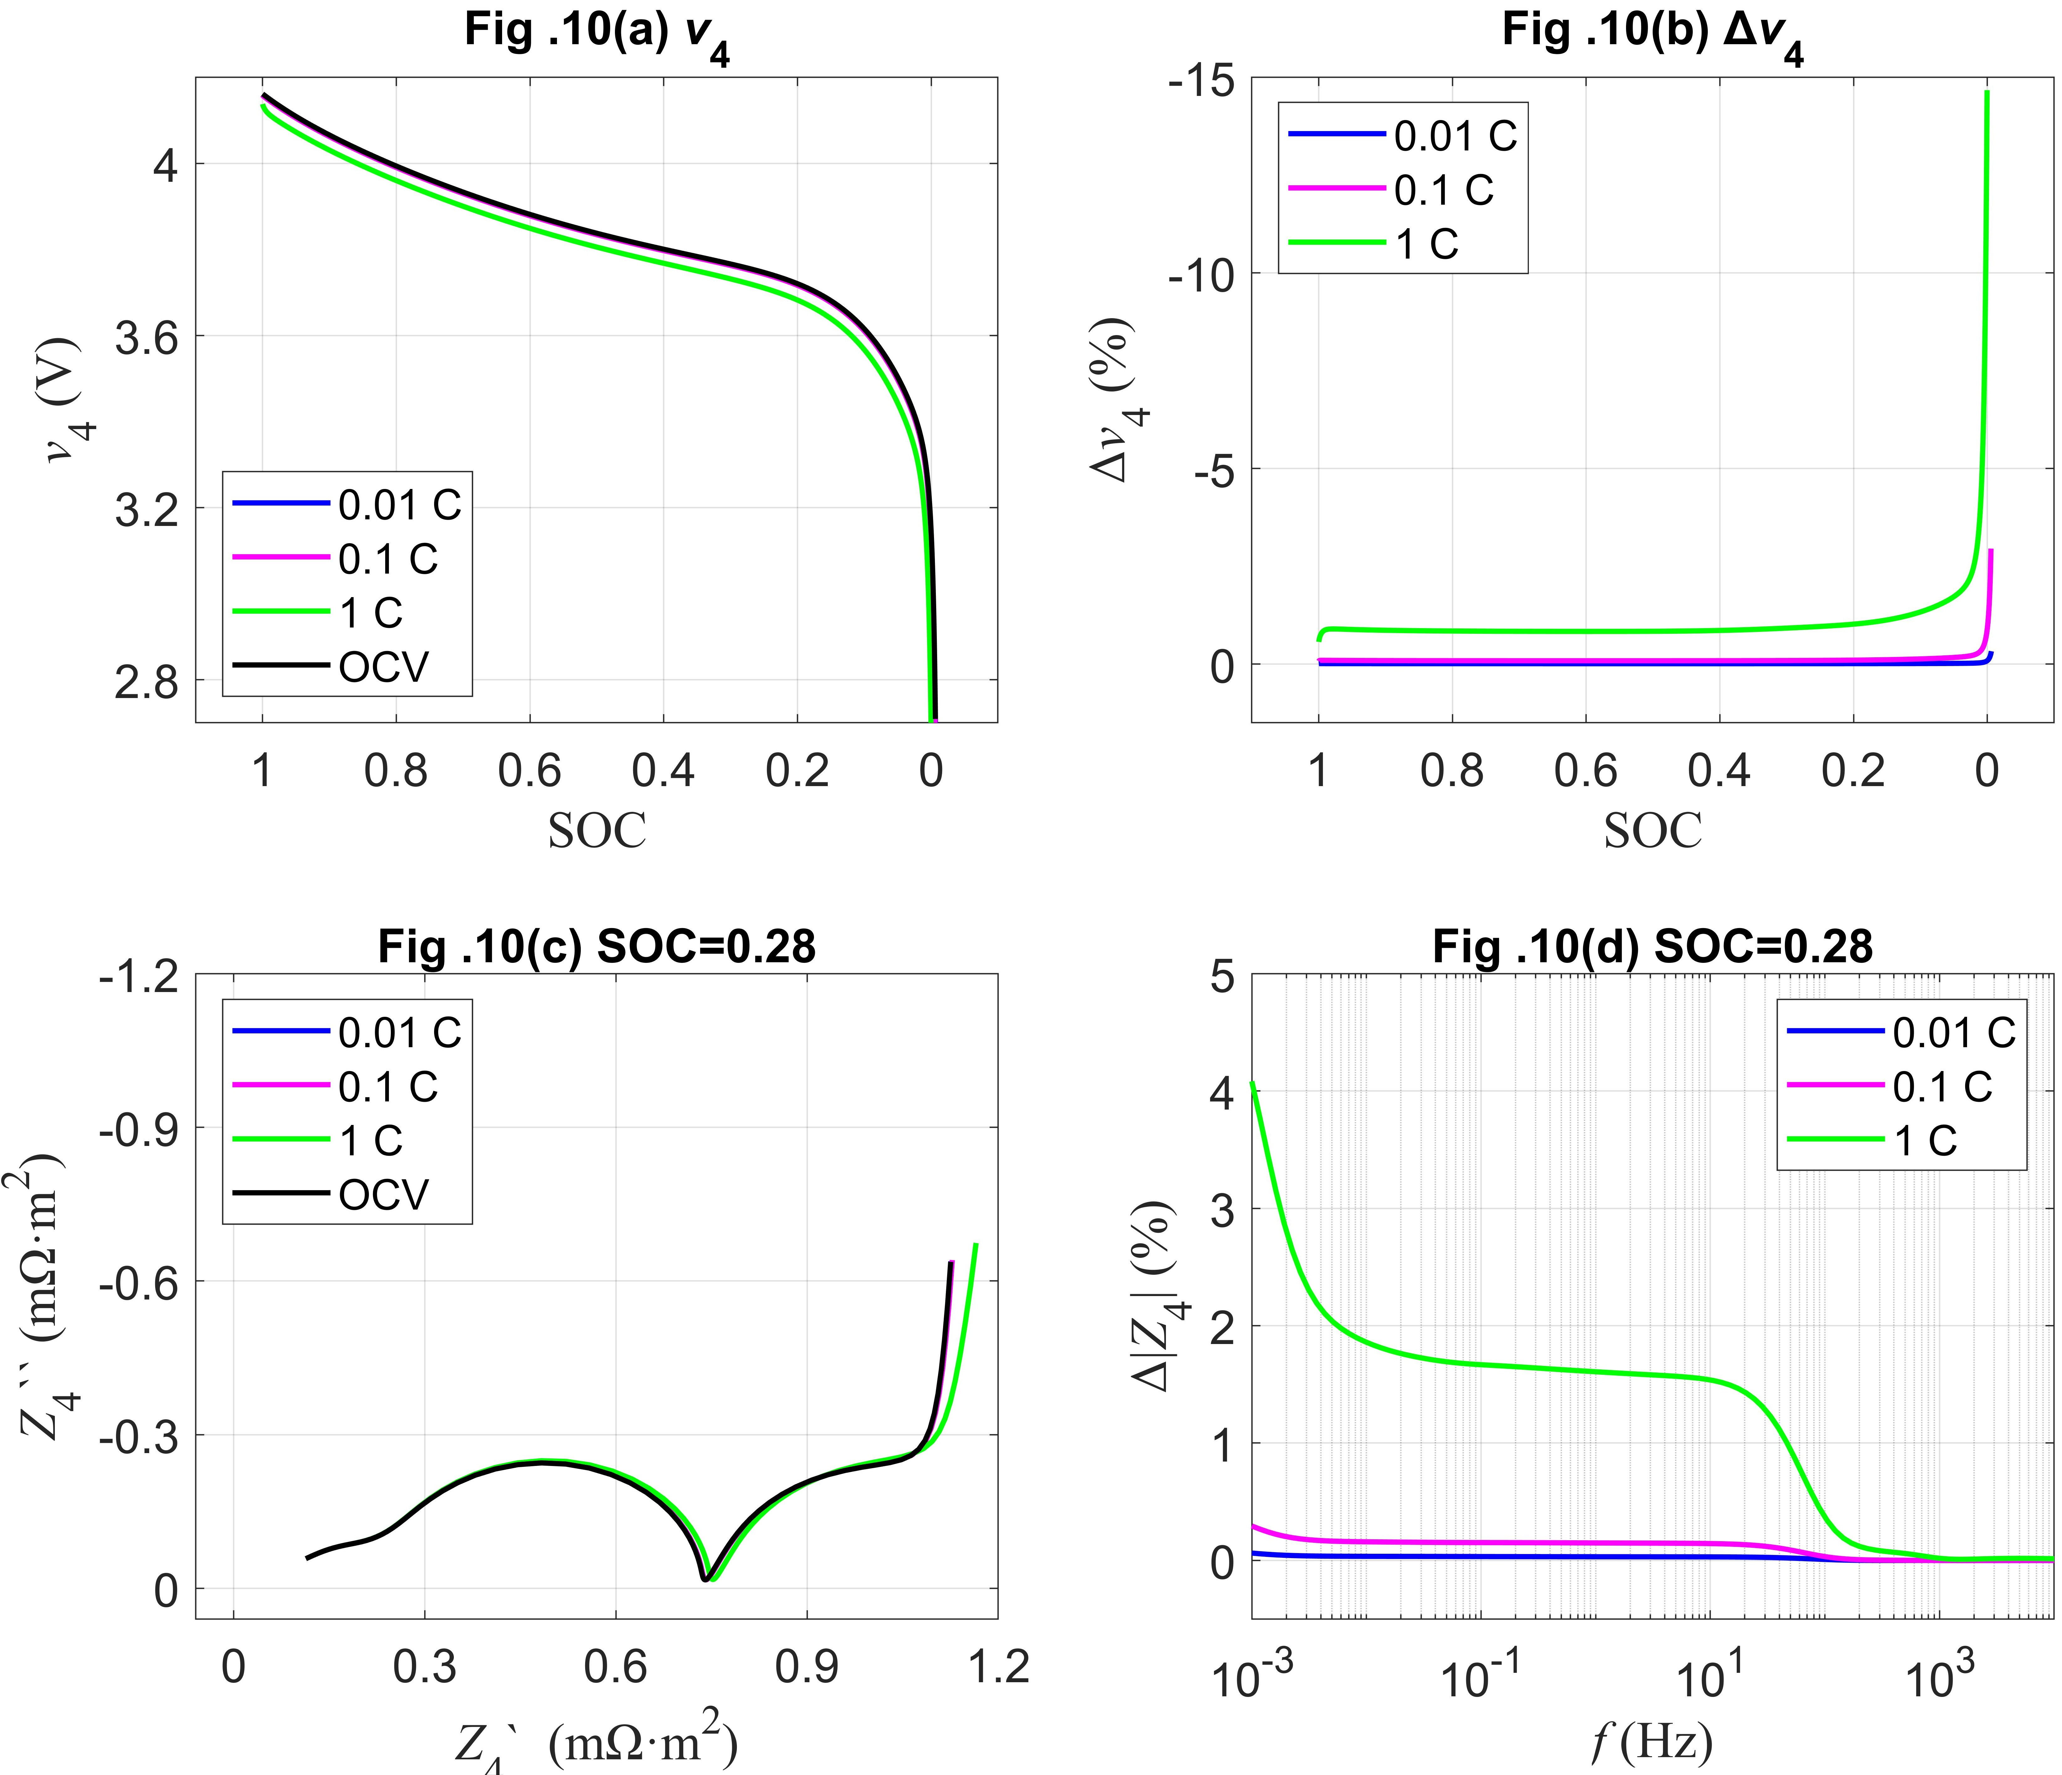

**Figure 6.** Simulating results of discharge curves and DEIS compared to the OCV situation for the LIB with respect to SOC at different discharge rates. (a) Discharge curves. (b) The relative deviation of discharge curves compared to the OCV situation. (c) DEIS. (d) The relative deviation of DEIS compared to the OCV situation. Herein, DEIS and SEIS are calculated at SOC = 28%.

#### (2) Simulation with modified parameters

By modifying the parameters, the user can obtain Figures 17–22 in Reference [1].

The user can directly obtain Figures 17−20 in Reference [1] by clicking on the Figure_17to20.m file. The location of the .m file is shown in Figures 1–2 and the corresponding simulation results are shown in Figure 7.

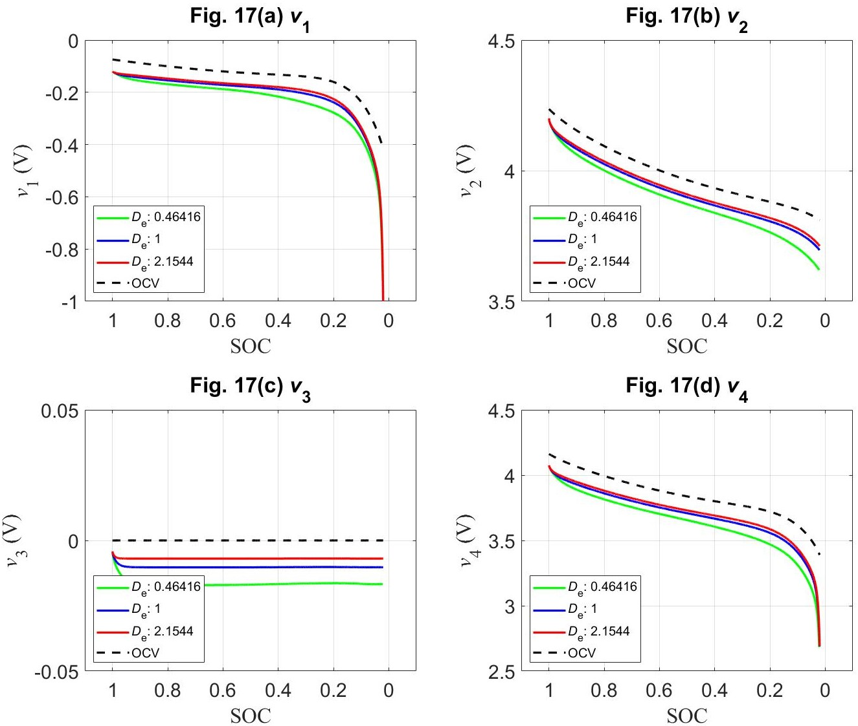

**Figure 7.** The terminal voltages *v*i(*t*) (i = 1,2,3,4) with respect to SOC and *D*e at 4C discharge rate, compared to the OCV situation: (a) *v*1(*t*) for the negative electrode; (b) *v*2(*t*) for the positive electrode; (c) *v*3(*t*) for the separator; and (d) *v*4(*t*) for the full cell.

## 3. References

[1] Yuxuan Bai, Qiu-An Huang, Zijie Wu, Juan Wang, Jingzhe Chen, Kai Wu, Jiujun Zhang, A unified framework to decouple charge transfer reactions in the Li-ion battery under dynamic conditions, J. Energy Chem. (2025).

[2] Marc Doyle, Thomas F. Fuller, John Newman, Modeling of galvanostatic charge and discharge of the lithium/polymer/insertion cell, J. Electrochem. Soc. 140 (1993) 1526–1533.

[3] Thomas F. Fuller, Marc Doyle, John Newman, Simulation and optimization of the dual lithium ion insertion cell, J. Electrochem. Soc. 141 (1994) 1–10.

[4] Marc Doyle, John Newman, Antoni S. Gozdz, Caroline N. Schmutz, Jean-Marie Tarascon, Comparison of modeling predictions with experimental data from plastic lithium ion cells, J. Electrochem. Soc. 143 (1996) 1890–1903.

[5] Jeremy P. Meyers, Marc Doyle, Robert M. Darling, John Newman, The impedance response of a porous electrode composed of intercalation particles, J. Electrochem. Soc. 147 (2000) 2930–2940.

[6] Marc Doyle, Jeremy P. Meyers, John Newman, Computer simulations of the impedance response of lithium rechargeable batteries, J. Electrochem. Soc. 147 (2000) 99–110.

[7] Yuxuan Bai, Qiu-An Huang, Kai Wu, Jiujun Zhang, Decouple charge transfer reactions in the Li-ion battery, J. Energy Chem. 92 (2024) 759–798.